Taisiia Olishevskaia
02/21/1997 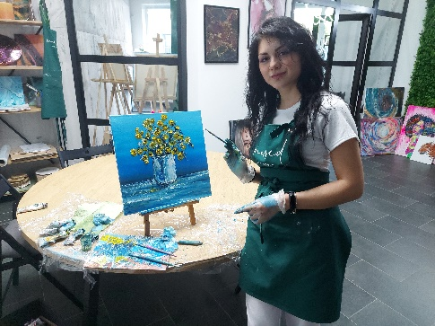
Kyiv
Education:
Kyiv University of Technology and Design. Master 2014-2019.
Faculty of Design.
Skills:
Possession of academic drawing and painting
Knowledge of the basics of composition
Photoshop, Illustrator, Corel Paint, InDesign, Code Visual, Figma.
Continuous learning and improvement.
Traditional painting and design graphics.
Experience:
Corporate identity development (logo, brand book, booklet, poster)
Game graphics (Concept art)
Print development
Teaching courses in web design, 2D drawing, fashion illustration, graphic design.

282821tm@gmail.com
+380664303177 (viber/telegram)

